Construction Waste Management through Lean Process

Name of Student

AMS 394 Lean Systems

Table of Contents
Introduction 3
Organization 5
Value Stream Map 6
Summary, Interpretation, and Conclusion 7
References 8

Introduction
Lean Architecture is the continuous process of reexamining and enhancing compositional strategy. It is the quest for better work by applying Lean principles to each part of training.
Purpose of the process
First, the process will seek to create a distinction between planning and implementation of construction strategy. While Lean has just demonstrated huge outcomes in the assembling and construction enterprises, there is a reasonable distinction amongst planning and building. As indicated by Ballard and Zabelle (2000), Designing produces the formula and Building readies the supper. This is the old qualification amongst arranging and doing.
The second purpose of this process is to ensure the design process results in modified means of processes that reduce wastage. The principles of Lean are in this manner altered in Lean Design to oblige the idea of the plan process. Ballard and Zabelle (2000) contrast planning with a decent discussion, from which everybody leaves with an alternate and preferable comprehension over anybody carried with them. The most effective method to advance this discussion (emphasis) and separate between positive (esteem producing) and negative (inefficient) cycle are a portion of the focal standards of Lean Design. Hansen and Olsson (2011) states that Lean reasoning in configuration has no less than two principle destinations: to locate the best outline to address the customer's issues keeping in mind the end goal to help viability, productivity and client fulfillment; and to characterize frameworks, structures and materials to guarantee viable, streamlined construction.
Lastly, is to ensure that lean design perspectives are considered throughout the architectural process.. Lean Design considers three points of view to portray the plan process (1) Transformation (change of contributions to yields); (2) Flow (stream of material and data through time and space); and (3) Value (the age of significant worth for clients), as opposed to the more customary perspective of the outline process as just a change process (Ballard and Zabelle, 2000).
The product of this lean process is reduced waste during building and construction process, and reduced expenses on raw material.
People Involved
People involved are, namely: property owner or dealer; architect who will prepare the map of the house based on clients’ requirement; civil engineer who will execute the construction; contractors and laborers; carpenters; electricians; plumbers; and painters
Why this process is a good candidate for a conversion to lean principles
Regardless of the way that the term 'construction and destruction squander' has been characterized as any sort of strong waste produced amid construction forms, lean construction thinking prescribes a more extensive meaning of waste to incorporate physical waste as well as waste identified with any wastefulness of gear or laborer execution created in a construction process, (for example, holding up time and transportation time) (Farrar et al., 2004)
Anticipated benefits for making this a lean process
Eliminating waste in a process is one of the best needs in the lean construction hypothesis (Farrar et al., 2004; Al-Sudairi, 2007). Notwithstanding worrying on the physical waste, lean reasoning particularly gives careful consideration to the waste delivered in a construction process. Undertaking supervisors may decipher squander as just physical construction squander which frequently incorporates material misfortunes.
In any case, there are different sorts of waste in a process, identified with the execution of pointless exercises by assets that reason extra expenses however don't increase the value of the item (Koskela, 1992).
Also, while lean principles center around process squander lessening and greatest esteem age, and maintainability; consequently, endeavors have connected with the decrease of building waste, in this way yielding cost investment funds

Organization
Participants
Participants will include: property dealer or owner architect who will prepare the map of the house based on clients’ requirement; civil engineer who will execute the construction; contractors and laborers; carpenters; electricians; plumbers; and painters.

Waste Categorization

Commonly Known

Occasionally Known

Commonly Known waste includes: defects, waste due to wait periods, waste due to design errors, excessive space/stock waste due to operations; excess materials, transport/handling time, activity delays; and rework.
Occasionally Known Waste includes: inventing work, over production, equipment wear and tear, safety costs, resting time, and clarification needs.
Source: Senaratne and Wijesiri (2008)

Value Stream Map
This Value stream mapping (VSM) is used to analyze, design, and manage the flow of materials and information required to bring a product to a customer.
The following is the proposed lean manufacturing technique that will ensure reduces wastages
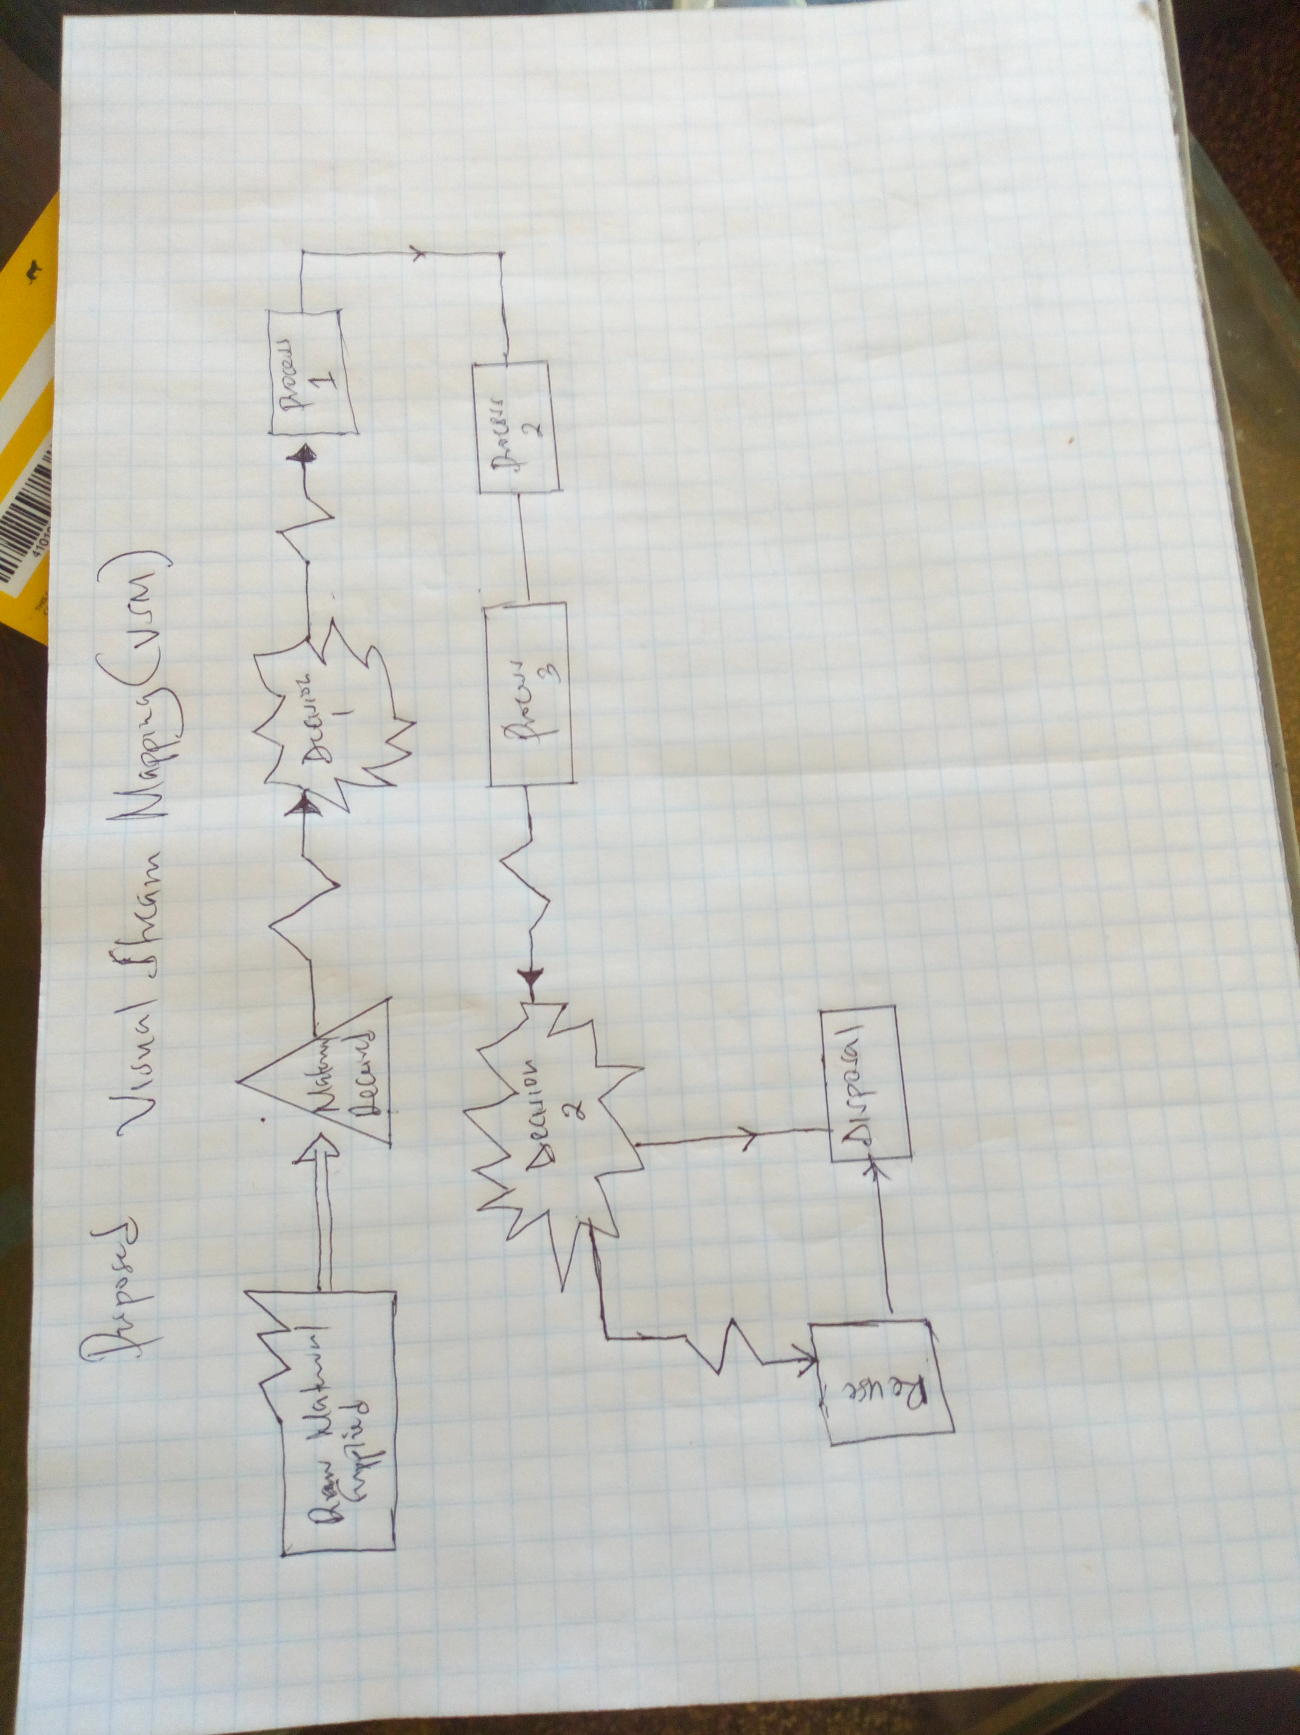

Summary, Interpretation, and Conclusion
In spite of the fact that the construction business witnesses a perceptible offer of squanders in its forms, a viable practice for diminishing them is infrequently performed. Be that as it may, lean construction considering, by thinking about an incorporated perspective of generation, efforts to demonstrate the significance of lean ideas in the outline and designing of construction forms.
In reality, a high offer of non-value-adding work in construction forms realizes great open doors for lean principles application. Lean principles connected in a construction process can have distinctive outcomes relying upon the process highlights. The best lean principles ought to be decided for usage in light of a thorough examination on the considered tasks. Moreover, changes or adjustments in the tasks may must be improved with a specific end goal to apply these standards in the contemplated construction forms in perspective of the uniqueness of the construction business. Be that as it may, the expenses of these alterations will dependably be significantly not as much as the advantages made by lean principles.
This proposal through lean construction processes seeks to: create a distinction between planning and implementation of construction strategy; see that the design process results in modified means of processes that reduce wastage; and ensure that lean design perspectives are considered throughout the architectural process.

References
Al-Sudairi, A.A. (2007) ‘Evaluating the effect of construction process characteristics to the applicability of lean principles’, Construction Innovation: Information, Process, Management, Vol. 7, No. 1, pp.99–121.
Ballard, G., & Zabelle, T. (2000). Lean Design: Process, Tools, & Techniques. Lean Construction Institute.
Farrar, J.M., AbouRizk, S.M. and Mao, X. (2004) ‘Generic implementation of lean concepts in simulation models’, Lean Construction Journal, Vol. 1, No. 1, pp.1–23.
Hansen, G. K., & Olsson, N. O. (2011). Layered Project–Layered Process: Lean Thinking and Flexible Solutions . Architectural Engineering and Design Management, 7(2), 70-84.
Koskela, L. (1992) Application of the New Production Philosophy to Construction, Center for Integrated Facility Engineering, Department of Civil Engineering, Stanford University, USA.
Senaratne, S. and Wijesiri, D. (2008) ‘Lean construction as a strategic option: testing its suitability and acceptability in Sri Lanka’, Lean Construction Journal, pp.34–48.

